Mother Lode Art Association Newsletter
March/April 2019
Upcoming meetings: March 18, 2019 and April 15, 2019
Meeting Time: 1:00 p.m. Location: Tuolumne County Library, 480 Greenley Road, Sonora

MLAA ARTIST DEMOS – Free of charge, after every meeting!
Please note the following demo program change:
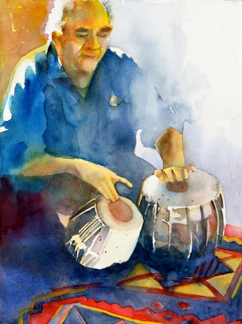
Elizabeth Ingebretsen’s watercolor demo, originally scheduled for February 18, had to be postponed due to severe weather that forced us to cancel our meeting on that day. Be sure to catch Elizabeth’s presentation on April 15 to learn why you should defy tradition and start your watercolor painting with your most intense color!
Patricio on Tablas by Elizabeth Ingebretsen
Elizabeth is a watercolorist and oil painter from Modesto and Carmel, CA. Liz loves to convey form with expressive color and with lost and found edges. Liz is a member of the California Art Club and shows with Venture Gallery in Monterey, CA. You can see more work on her Instagram Page, Elizabeth Ingebretsen. Liz’s demonstration will be of a landscape addressing use of color and how to stay loose with the medium.

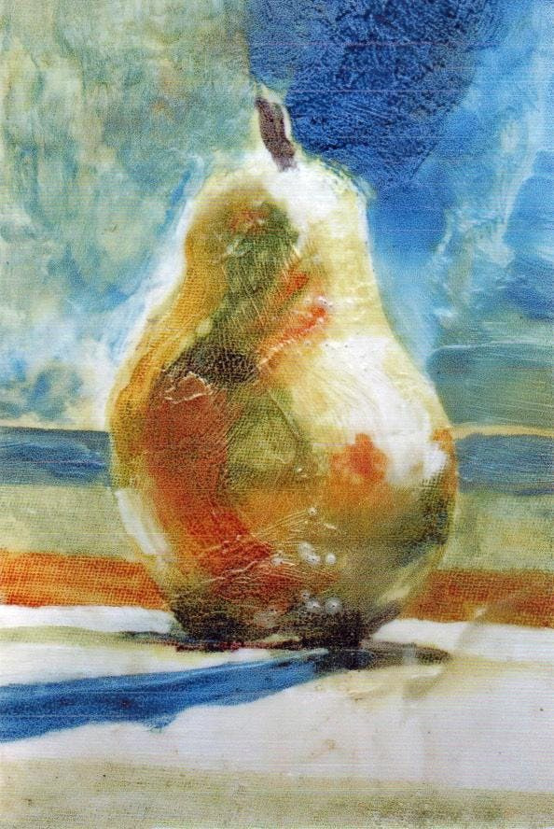
Our artist for March 18 is Carolyn Macpherson. Carolyn was formerly a Mother Lode resident and supporter of MLAA. She now resides in Washington State where she practices and teaches an amazing variety of art techniques. She returns to the Mother Lode in March and many MLAA members have enjoyed her demos in past years! On the 18th, Carolyn will be demonstrating an innovative technique which resembles encaustic, using Dorland cold wax mixed with oil paint and medium. If members wish to try it along with her she will be bringing all supplies, including Dorland wax, and anyone could try or members could bring their own oil paints and medium. Carolyn will be teaching various wax techniques at Town Hall Arts in Copperopolis on March 20-21-22; cntrl/click on the following link to visit their website at http://townhallarts.com/calendarclassesevents.html for information.
Image by Carolyn Macpherson
President’s Message
MLAA BOARD 2019

President: Linda Happel
209-532-7240
lindaleehappel@gmail.com
Co Vice Presidents:
Barbara Conley, 209-532-0207,
Barcon@inreach.com
Bob Feigen, 209-604-0762, robertfeigen@gmail.com

Secretary: Kim O’Connor, dkoc@mlode.com

Treasurer: Juliana Tillman
209-586-9342
calgoldcountry@msn.com

COMMITTEE CHAIRS

Art Show Chairs: John Sharum, Jsharum@aol.com,
Lorna Hunt, lhunt@mlode.com;
Program: Peggi Kroll Roberts peggi@krollroberts.com
Membership : Juliana Tillman
209-586-9342
calgoldcountry@msn.com
Newsletter/Website Editor: Maureen Carden, 209-533-1248
cardenmaureen@gmail.com
Historian: Loretta Pagni
209-536-0247
Plein Air Coordinator:
Susan Lea Hackett, 209-965-0253
Donh1@mindspring.com
Venues: Barbara Conley Barcon@inreach.com, Pat Gray peliart@aol.com
Scholarship/Publicity: Celia Niemerow, celiancelia@gmail.com

After a series of storms that left many members snowed in and caused us to cancel our February meeting, and a round of rain and hail that resulted in historic flash floods in the area this past week, we’re looking forward even more eagerly than usual to the beautiful days of Spring in the Mother Lode. Despite the weather, the art show committee has made amazing progress. Please read John Sharum’s art show report for details. One important innovation: with the support of the Tuolumne County Arts Alliance, we will be using SmartEntry to process show entries. Don’t panic, assistance will be available if you need it! The TCAA have agreed to also assist with marketing and the student’s art section. I cannot thank the TCAA and especially Laurie Livingston enough for the information and assistance they have already provided. This will be a great partnership and I encourage all MLAA members to join the TCAA. Together we can keep art alive in the Foothills.
We have two great demos to look forward to. Our good friend Carolyn Macpherson will demonstrate an innovative wax technique in March. And in April we are delighted to welcome watercolor artist Elizabeth Ingebretsen. Elizabeth, thank you for rescheduling after the February meeting was snowed out.
We are soliciting quality items for our raffle baskets for the art show. If you have a suitable donation, you can bring it to the meeting. We will also be collecting art from the members for the raffle. Last year the raffle was extremely successful utilizing art from our talented members and we hope to raise even more money for funding of art supplies or projects in the schools. This year our goal is funding for the high school art departments.
Thank you all and look forward to seeing you on March 18th. If anyone would like to provide refreshment for the meeting, we are always grateful!

Linda Happel, President

We love to serve light refreshments at our meetings. Please feel free to bring your favorite finger food!

Art Show Report by John Sharum
The 66th Anniversary Art Show is coming along nicely. The Committee has met twice since the last newsletter and we have begun our cash donation effort. Letters are going out to previous contributors and we continue to encourage all of our members who have special connections to businesses that you think might like to support arts in Tuolumne County to let us know. Linda and I will be happy to follow-up in person or by letter based on your introduction.

We are also looking for members to bring new items to our meetings for raffle basket prizes. Bags will be available at our March 18 MLAA meeting to collect items. Categories so far for the raffle are:
- Movie
- Wine
- Gardening
- Art Supply
- Spa
- Food
- Books

We are partnering with Tuolumne County Arts Alliance to use the same electronic entry system that they use for the INFocus Show. It is cost effective and more efficient. For members that need extra help to use the system, we will be doing future trainings and actual entry sessions.

TCAA has also been helpful in identifying how to reach student artists for our 14-18 year old art show that will parallel our adult show. Entries will be open June 1 through September 1. We will have sample prospectuses available for view at our meetings and links to the entry site will be on our website once the prospectus is ready.

Lori Hansen has accepted being one of our Judges. We hope to announce our second Judge at our general meeting.

As always, we will circulate a sign-up sheet for those that can volunteer before or during the show. Your continued support through your time, your contributions, and your wonderful art will make this show a success. Thank you!

John Sharum and Lorna Hunt
Art Show Co-Chairs

From the Aloft
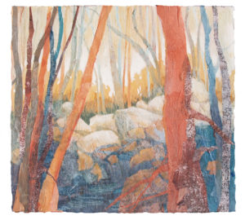
In the Grove by Lynn Slade
In the Window

Award winning Watercolor Collage artist, Lynn Slade is featured in the Aloft window during March and April. Lynn uses rice papers and textured papers that she makes herself, to use in her collages, layering one piece of colored paper over another to create a tactile experience as well as a visual one.

Lynn will be offering a watercolor collage workshop at her studio in Pioneer in April 5th, 6th and 7th. Call her at 209- 295-4667 if you’d like to get creative with collage.

Visit www.lsladeart.com to learn more about Lynn and her techniques.

ALOFT Art Sale
Our big sale is coming up on April 1st. Aloft artists will be digging “Behind the Couch and Under the Bed” for all those treasures that you may have never seen, all priced to sell. A great opportunity to add to your collections!
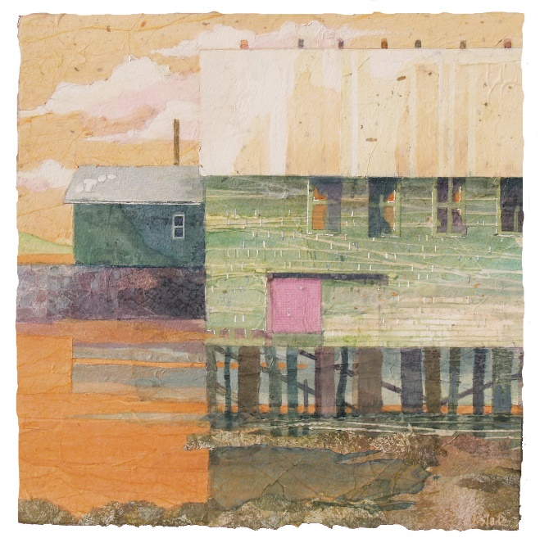
The Aloft Art Gallery opened in 2008 to provide Mother Lode artists with a venue to display and sell their work. It is member-run. Artists must be members of the Mother Lode Art Association to apply for Gallery membership. For more information go to www.aloftartgallery.com
Farthest East by Lynn Slade

By Lorna Hunt, Aloft Liaison

Museum Happenings by John Sharum
I went to the Gauguin and Monet shows at the De Young—Well worth your effort to see!!!! -- John
Crocker Museum
• January 27-April 7, 2019: History, Labor, Life (Over 90works from 1963 to 2000 by influential printmaker, Jacob Lawrence)
• February 17-May 12,2019: The Roaming Eye –International Street Photography (70 works by 40 Street Photographers)
De Young Museum
• November 17-April 7, 2019: Gauguin: A Spiritual Journey (More than 50 paintings, wood carvings and ceramics)
• February 16-May 27, 2019: Monet: The Late Years (50 paintings, mostly from 1913 to 1926, including 20 works from Musee Marmottan Monet in Paris)
Legion of Honor Museum:
• April 6-September 8, 2019: Early Rubens
SFMOMA
• Through April 28: Wayne Thiebaud: Paintings and Drawings ( Works spanning 50 years of his career)
• Through May 26: Louis Stettner: Travelling Light (Retrospective of 80 years of work capturing everyday life in
New York and Paris through photography)

A Word About Dues
MLAA dues are due at the beginning of the calendar year. A year’s membership will now cost $20 for everyone, regardless of age. Thanks for your understanding.

A Word About the Newsletter
For reasons of economy and efficiency, we no longer offer the option of receiving the Newsletter by mail. Hard copies will be available upon request at regular meetings. Dates and times of meetings and details of programs are published in the Union Democrat and the Weekender. Be sure we have your correct email address!
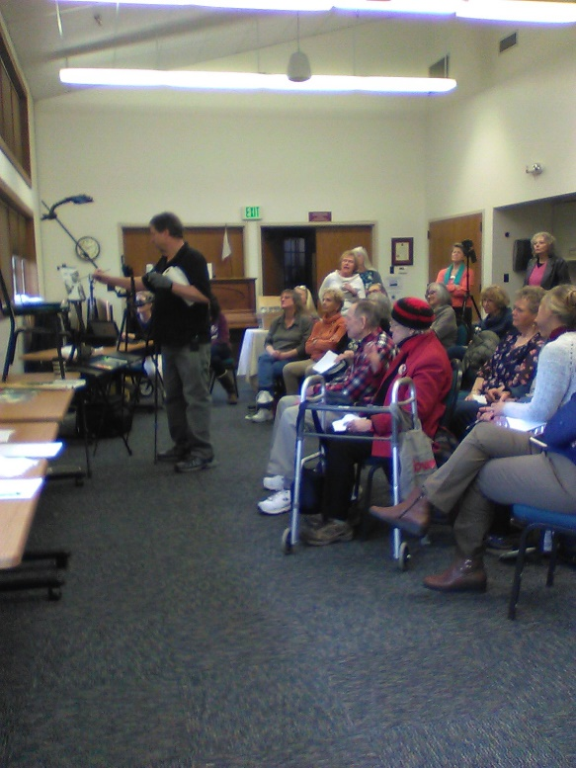
Minutes of the General Meeting, January 2019
Standing room only for Ray Roberts” demo!
By Kim O’Connor, Secretary
The meeting was called to order by Linda Happel at 1:00. Several guests welcomed, including watercolorist Randy Kirkbride, Kristi Popovich, fiber artist Cynthia, Paula, Jeffer and Grace.
2. Previous meeting minutes were approved as written.
3. Juliana reported that MLAA funds total $7,242.93.
4. As Co-chair of the Show Committee, John gave an update on planning activities for the 66 th Annual Art Show. We will be expanding support for the schools with a goal of generating more profit to award local high schools for art supplies. Part of this outreach to students includes the addition of a Student Category. There will be no entry fee for students, and they are limited to one entry which will be juried. Monetary awards will mimic other categories. A volunteer sign-up sheet was passed among members. John shared that last years’ show generated $1,200 and says we will ask for art donations again and announced that the committee also plans to put together themed baskets for raffle, and is asking members to contribute new items. Themes include: Movie, Wine, Gardening, Books, Art Supply, Spa, and Foodie. Please bring donations for the baskets to monthly meetings over the next several months.
5. Celia said that the scholarship program to schools is a work in progress. Last year four schools were awarded $250 each from show proceeds. This year it will be decided which of our area high schools are to be recipients, and how much money to each will depend on show revenues.
6. Maureen announced that the MLAA Newsletter goes out via email and due to expense will no longer be mailed. Copies will be available on the table at the monthly meetings. Information was given that our organization has meeting notices in the Union Democrat and the Weekender with details of date, time, and scheduled program. She asks that members please let her know of any email address change.
Maureen would like to include member artwork in her newsletters and says artwork and bios can be submitted to her.
7. Susan Lea Hackett announced that the Plein Air group hopes to be out painting in February – weather permitting! She received a grant and will be going to teach art in Mexico for 10 days in March. She recommends watching for email organizing plein air events which are Tuesdays, and is open to suggestions for sites or folks willing to host. The Plein Air group that was out and about town during the art show was very successful and will likely be scheduled again. See Susan to be added to her email list if interested in location painting.
8. As Program chair, Peggi arranged for husband and renowned artist, Ray Roberts, to demonstrate today! She has watercolorist Elizabeth Ingebretzen scheduled for February and is working on others.
9. Barbara reported that venues are filled for the year. Robin sold paintings at Sonora Anti-Coag,Susie at Aloft, and one painting sold out of Pac-n-Copy.
10. Juliana reported on membership: it’s time to renew! Member dues have increased to $20 for all.
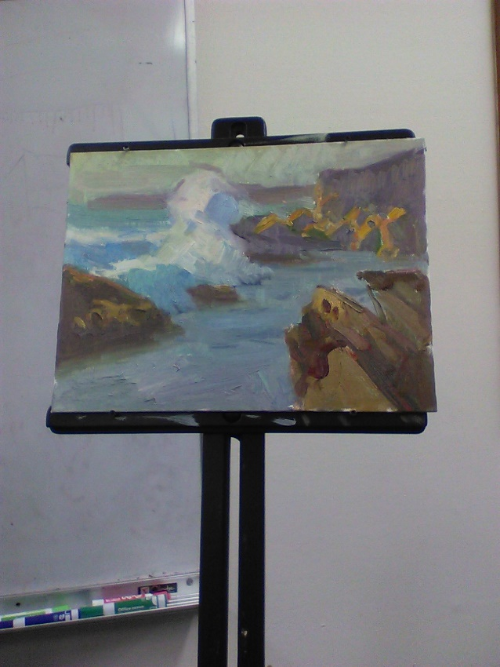
11. In other announcements, Susan Kendall is hosting free painting classes at the Oak ValleyPresbyterian Church on January 28 th , February 4, and February 11 from 1-4 o’clock. She will setup a still life for the first two classes, and watercolor will be the focus at the 3 rd class. She has all supplies available and classes are free although there is a suggested donation of $5.
12. Susan shared a lovely painting by Rana Ford from a Plein Air outing in Columbia.
13. Refreshments were enjoyed by all before our guest artist presentation.
14. Guest artist Ray Roberts painted from a projected and self-edited photo from Pt. Lobos. He began by saying, “most important in painting are light and dark patterns.” He began with dark shapes and “colorized” later. References to three small color sketches which were done on site allowed him to correctly recreate a larger version of a gorgeous ocean spray splashing off rocks in the foreground. See Ray’s work at left!

15. Meeting closed at approximately 3:30.

Announcements
The Calaveras Gem and Mineral Society is requesting donations of small to medium artwork by March 18th meeting. They are having a gem and jewelry show on March 23-24 at the Calaveras fairgrounds. The donations would be used for the raffle. Please call or email Loretta Pagni to donate: 209 536 0247,
LorettaPagni@aol.com
Visiting the area, looking for something to do? Town Hall Arts offers a wealth of classes including many drop-in classes and sells a wide range of art supplies. Carolyn Macpherson, MLAA’s guest artist for March, will be teaching her innovative wax painting techniques at Town Hall Arts in Copperopolis on March 20-22. Cntrl/click the link: http://townhallarts.com/calendarclassesevents.html for details, or call 209 785 2050 or email larry@townhallarts.com.
The Amador County Arts Council is sponsoring a full day of varied art instruction on March 30. Check out “A Tastes of the Arts” at https://www.amadorarts.org/our-events/a-taste-of-the-arts/ .
The St. Vincent de Paul Society in Amador County invites all artists to apply for space at their Spring “Art in the Foothills” on Saturday, April 27, 2019 from 9:30 to 3:30. The show will be held at Saint Katherine Drexel Church, 11361 Prospect Dr., Jackson, CA 95642. Booth fees are $60 for a 10‘ x 10‘ space. We will except applications through March or until full. Go to our website at www.svdpartinthefoothills.com for an application or information. This is a fundraising event for SVDP.
IN FOCUS PHOTOGRAPH SHOW AND EXHIBITION, March 11-23, Angelo’s Hall, open noon to 5:30. Sponsored by our partner, Tuolumne County Arts Alliance, and one of their most successful events. Go and see some beautiful images. Check out this event online at www.infocus-tcaa.org .

MOTHER LODE ART ASSOCIATION MEMBERSHIP APPLICATION

Fill out the membership application and bring it with your check to the next meeting or mail it today. Thank you. If you are already a member, cut this out and pass it on to someone you think might be interested in becoming a MLAA member.

Name______________________________________________________________
Address_____________________________________________________________
City______________________________State_____________Zipcode__________
Phone__________________________Email_______________________________
Membership Categories: Individual $20.00 General _____ $50.00 Patron _____
$100.00 Benefactor ____ $250.00+ Lifetime _____ (check one) Business $50.00
Patron _____ $100.00+ Benefactor ______

Please make checks payable to: MOTHER LODE ART ASSOCIATION. P.O. Box 5140 Sonora, CA 95370

We encourage you to enjoy the wonderful Artist Demonstrations and Programs we have the 3rd Monday of each month at the Tuolumne County Library, Greenley Rd., Sonora. Meetings are usually at 1:00 pm.

